NAME: MOHD SHAVAIZ

COURSE: BUSINESS ANALYST

EMAIL: [Mdshavaiz352001@gmail.com](mailto:Mdshavaiz352001@gmail.com)

PHONE: 8126243134

**Triangles Data**

The TRIANGLE Stable is described as follows**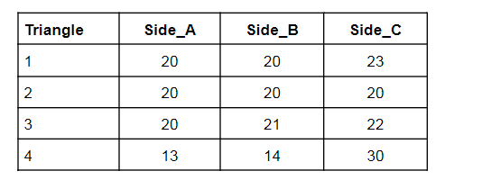Questions:1** Write a query to create the TRIANGLES table. (Note: In answer, submit all the table creation queries.)

**ANSWER 1)-**

THIS IS HOW I MADE TABLE AND INSERTED THE VALUES:

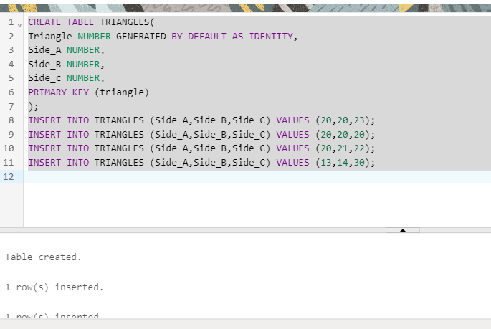

HERE’S THE SOLUTION OF IT…

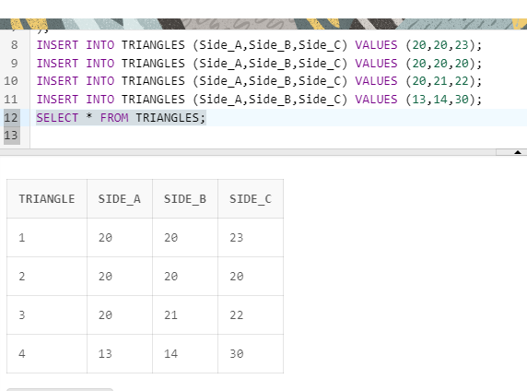

**Q2.) Write queries to get out put as per required:**

1. Write a query to obtain the sum of side_A of all triangles.

**ANSWER2)**

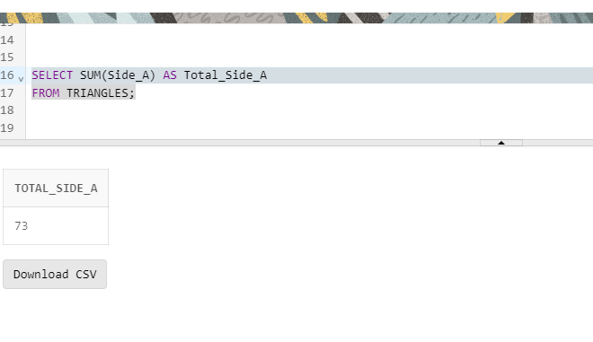

ii)Write a query to obtain an equilateral triangle from the table.

**ANSWER ii)**

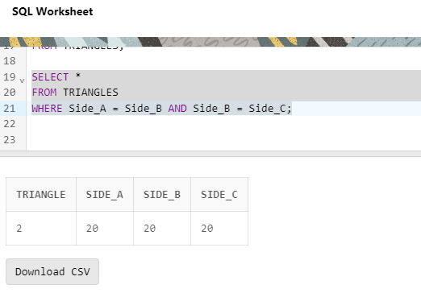

iii) Write a query to obtain an isosceles triangle from the table.

**ANSWER**

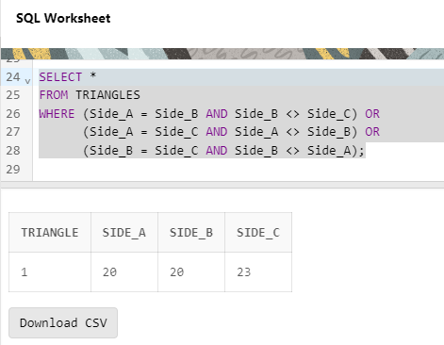

iv)Find the no. of triangles in the table.

**ANSWER**

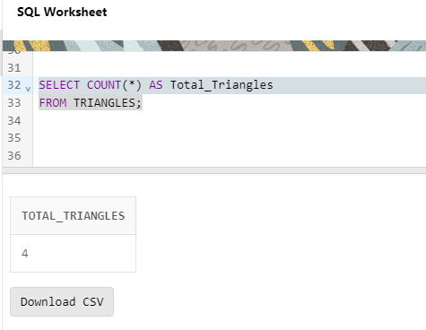

v)Find the length of side_B of Triangle 3.

**ANSWER**

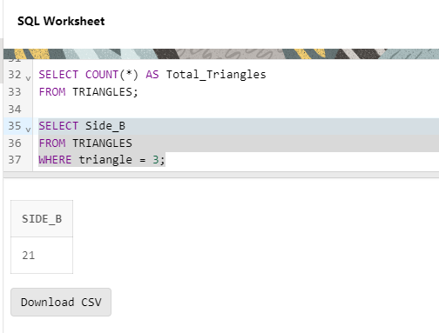

**PART 2. Employees Data**

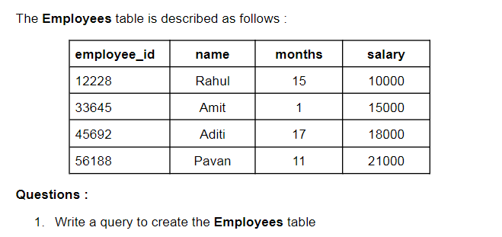

**ANSWER1)**

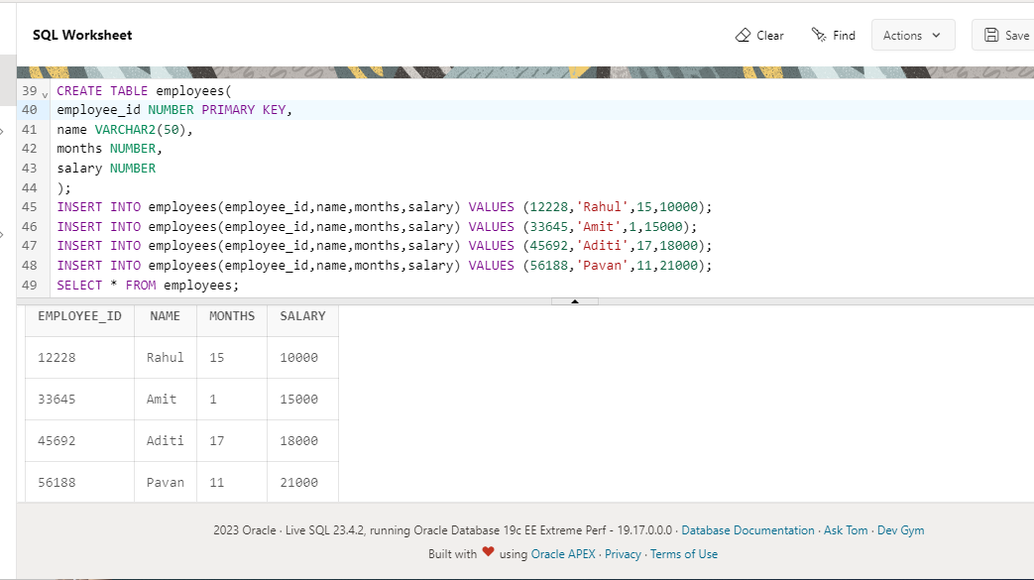

2. Write queries to get output as per required:

i) Count the total no. of employees.

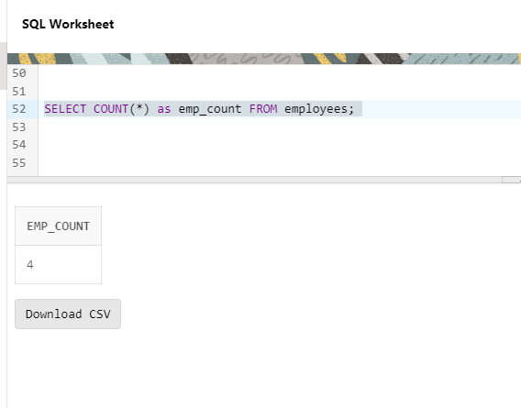

ii)Find the salary of Rahul.

**ANSWER**

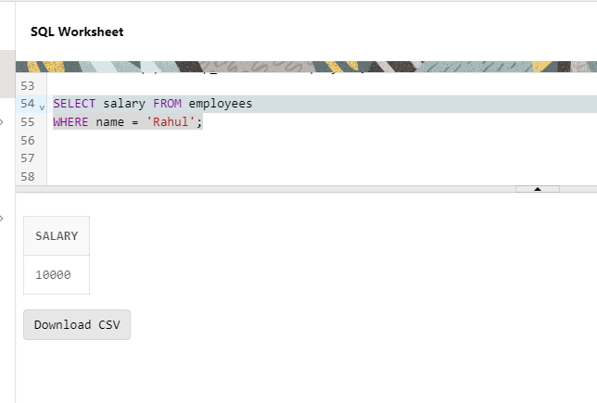

iii)Set Amit’s months to 12.

**ANSWER**

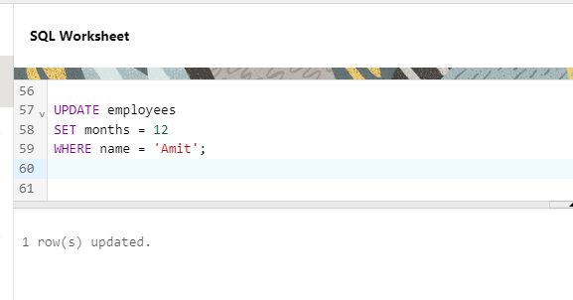

iv)Find the sum of salaries of all employees.

**ANSWER**

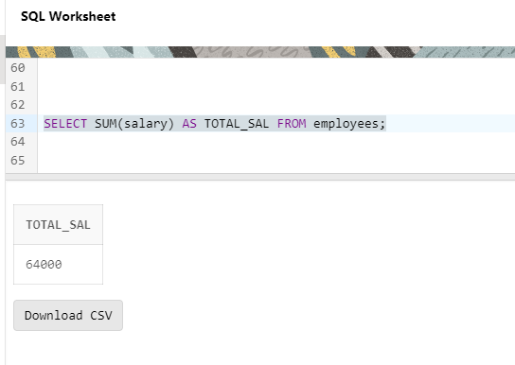

v)Find no. of employees whose name starts with ‘A’.

**ANSWER**

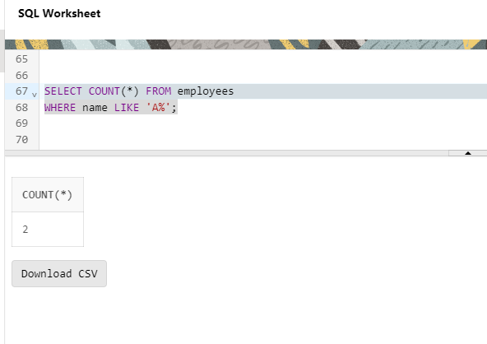

**END_OF_PROJECT**